**WEEK 6: 1.ReactJS-HOL (Solutions)**

Estimated time to complete this lab: **30 minutes.**

Create a new React Application with the name “myfirstreact”, Run the application to print “welcome to the first session of React” as heading of that page.

**Hands-on Solutions:**

* After creating a new React Application with the name ‘**myfirstreact**’. Opening the App.js

File and then implementing the given code.

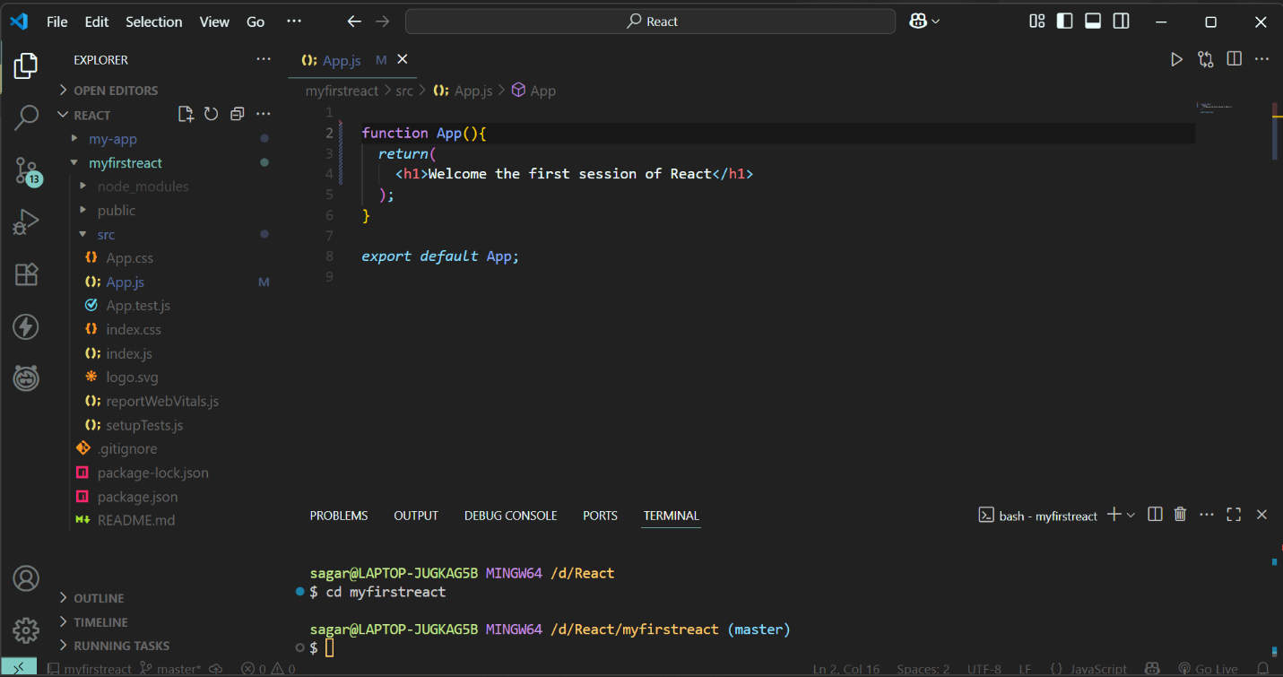

* Running the ‘**myfirstreact**’ application:



